After A 7-Year Old Girl is Injured in A Daytime Shooting, West Harlem Community Members Wonder What’s Next?
More NYPD officers are being deployed in the neighborhood, but some residents wonder if this is enough.

Residents of Hamilton Heights are feeling on-edge and frustrated after 7-year-old Fatou Keita was injured in the crossfire of an alleged gang-related shooting, leaving her hospitalized. The shooting took place near the corner of West 145th and Bradhurst Avenue, just after 3 PM on November 11.

19-year old Daniel Idowu and 17-year-old True Womack fired off guns in broad daylight and struck the little girl. While authorities and NYPD data cite falling crime statistics, the community’s lived reality tells a different story—one punctuated by a growing sense of urgency.

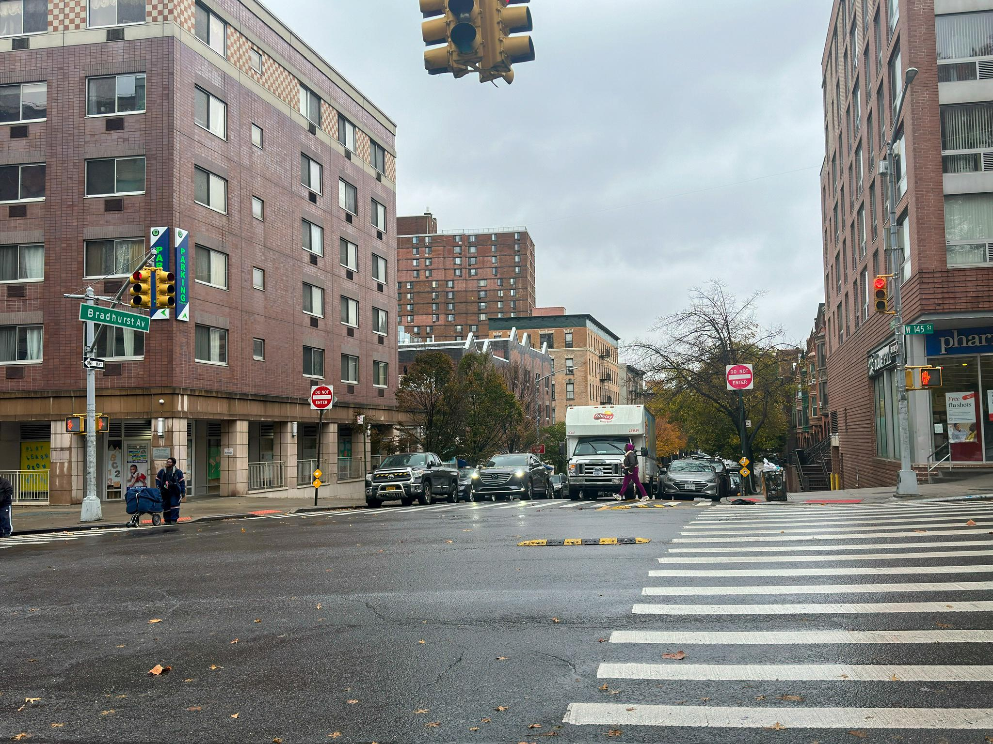
The corner of West 145th and Bradhurst Avenue near where a 7-year old girl was injured after an alleged gang-related shooting.

Ryan Bauer-Walsh, an artist and community leader who runs the Hamilton Heights Neighborhood Forum on Facebook, said people’s needs aren’t being met.

“I don't think crime is significantly higher or lower either way,” Bauer-Walsh said. “What I do think is different is when you have shootings that happen during daytime hours in broad daylight. I find that to be odd. It illustrates that people at a certain point are more desperate.”
The shooting underscores a disconnect between falling crime statistics and residents’ frustrations. While data suggests a decline in violence, locals argue it doesn’t reflect their lived experiences. Now, the community is pushing for tangible solutions, stronger neighborhood policing and community outreach to prevent further tragedies.

“As alleged, Daniel Idowu and True Womack callously shot at individuals on a crowded Manhattan sidewalk, seriously injuring a 7-year-old innocent bystander,” said District Attorney Alvin Bragg. “Thankfully, the child lived and brave police officers were able to act quickly.”

Bauer-Walsh said he’s spoken with council member Shaun Abreu and 30th precinct captain Cary Rose to implement solutions including hiring twelve additional police officers. The 30th precinct covers West Harlem including Hamilton Heights, and Sugar Hill, this is the sixth shooting incident this year. The 32nd precinct saw a 27% decrease in shootings compared to last year.

“One of the things was that I wanted the officers to have better social cues with their neighbors and to do actual outreach,” he said. “We sat down and talked about what the 30th precinct is doing and what they’re doing differently. Cary Rose told me they hired twelve new officers.”

David Kennedy, a criminologist and professor of criminal justice at the John Jay College of Criminal Justice said preventing violence means holding conversations with the groups involved.

“Effective near term violence prevention means effective intervention with those groups, the behaviors and acts that drive violence,” he explained. “There are ways that law enforcement can engage with those groups and ways that community actors can engage with those groups.”

West Harlem resident and music producer, Christian Jones, 49, said until a better dialogue is hosted between the NYPD and community members, there will be a lack of tangible results.

“Until both sides are in one room, and that discussion takes place where it’s an open dialogue. Where it can be, frankly, said that we don’t trust the police. Neither one of us can continue doing what we’re doing if we want to see anything change and then just go from there,” he said.

The shooting took place on the border of the 30th and 32nd precincts, something Bauer-Walsh said begs the question of which precinct responds when a crime occurs and how multiple precincts go about handling communication.

“We need somebody to be able to work with other precincts. The confusing thing to me is, I thought the NYPD was the city. You have to stay within your own jurisdiction. What happens? You stop pursuit at the border of the precinct?” he said.

Councilmember Yusef Salaam, who represents the 32nd precinct where the incident took place, called for changing public safety laws to keep Harlem safe and address violence unfolding amongst the youth.

“Our office is working diligently with the NYPD and various community organizations that are committed to pursuing changes to laws that will better protect our community and hold offenders accountable,” he said as reported by the New York Post.
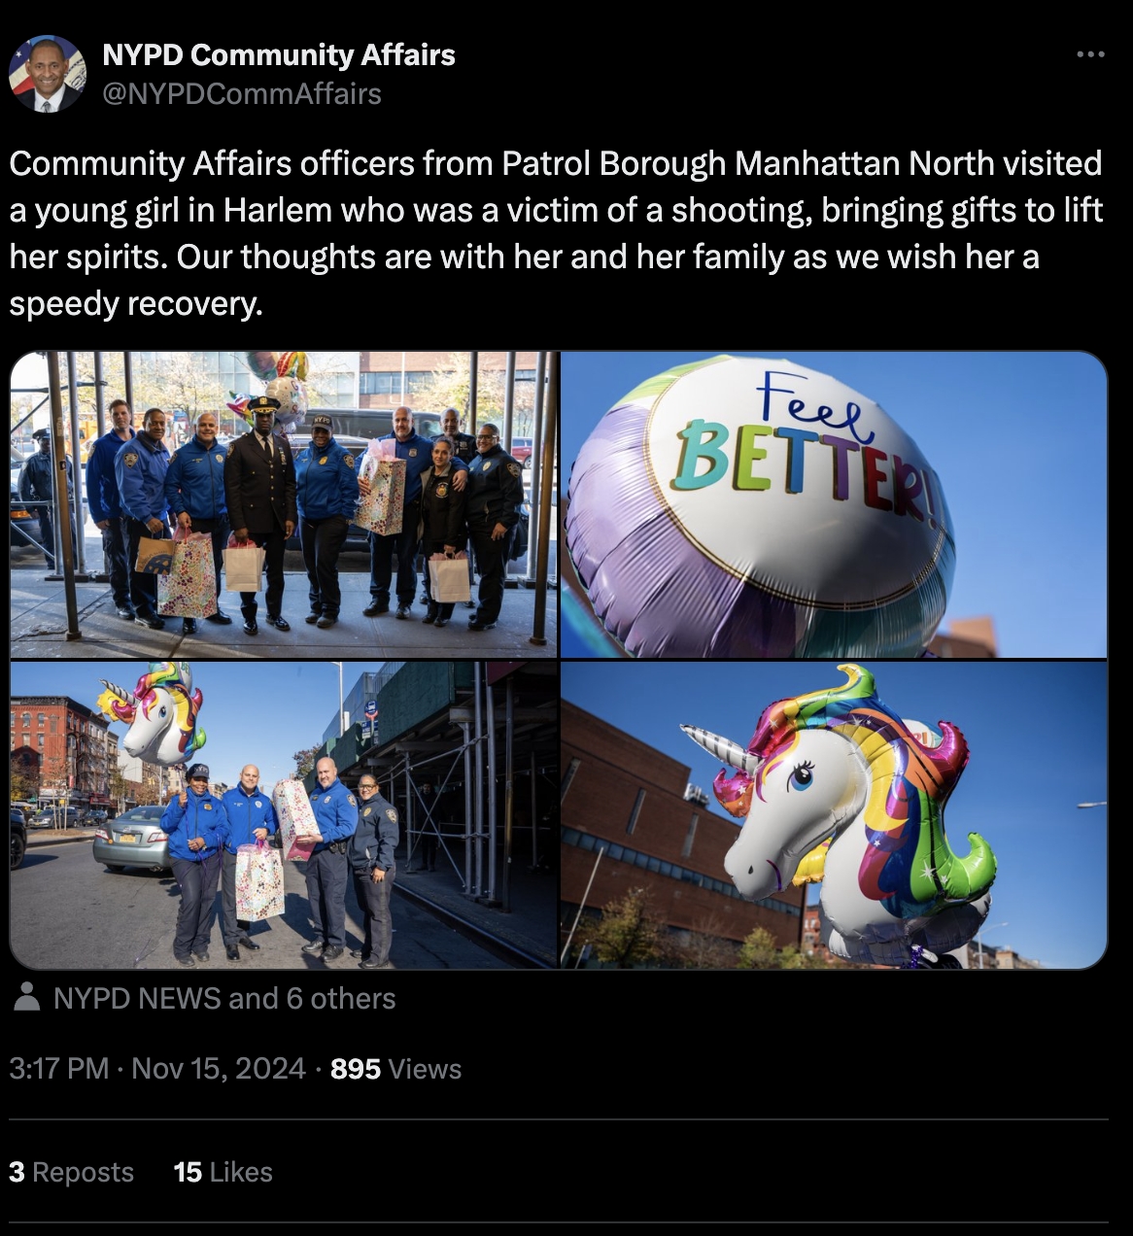
Community Affairs officers from Manhattan North visited 7-year-old Fatou Keita in the hospital posting these photos on X.

At a recent community board 9 meeting, residents expressed concerns that funding for after-school programs is one of the larger crises in the neighborhood. Bauer-Walsh said people have ideas but the problem becomes who will ultimately put solutions into place and fund them.

“Sometimes when they have solutions, they don't come up with a plan of action to execute them,” he said. “Tell me how we can actually implement your ideas. Because if you throw an idea out there, I need to know where we're going to get that funding from.”

With few neighborhood resources in place like the Jackie Robinson Recreation Center, Jones said it comes down to maintaining what is already available rather than building new solutions from the ground up including getting young people involved.

“There's an abundance of young people going in and out of there, so if there was a way to get them more involved in programming,” he said. “I don't know exactly how or what amenities those would entail, but I know that they've been employed in this city before.”

Kennedy said that violent crimes involving young people often get community members to take action.

“The public pays particular attention and tends to be greatly more concerned when violence involves young people,” he explained.

Laura Davis, 34, a freelance operations consultant, said that a lack of neutral third-spaces, whether religious or otherwise, pose a broader issue.

“As the decades have gone by as well, less and less people are involved in religious groups like churches and synagogues and things that have usually been third spaces that have been available for adolescents and for families,” she said. “People are less inclined to go to those, but also we need more than just religious space.”

Jones fears without changes implemented, the neighborhood will continue to see violence.

“The approach that is employed now doesn’t seem to be working,” he said. “It seems like it's reverting back to what the neighborhood was like in the 90s and early 2000, when it was pretty much a rogue neighborhood.”

Bauer-Walsh said he hopes that the community can get ahead of the pressing issues involving young people before more tragedies occur.

“I would say if you're doing that, then your stakes are really high. Your needs are not being met. Why are we not meeting your needs? How can we help?” he said.

Sources

Ryan Bauer-Walsh
Artist/Actor
rbauerwalsh@jupitertheatre.org

Laura Davis, 34
Self-employed (freelance operations consultant)
laura@uptownconsulting.co

Christian Jones, 49
Music producer/songwriter
mrjones2u@yahoo.com
(347) 471-9700

Professor David Kennedy
Criminologist, John Jay School of Criminal Justice (CUNY)
dakennedy@jjay.cuny.edu

