Spot #2 African American Day Parade, 389 words
September 15, 2024
By Emma Rosenberg

Political Leaders and Voting Take Center Stage During 55th African American Day Parade

Spirits were vibrant at the 55th African American Day Parade in Harlem with a resounding message. This year’s theme: “Good Leaders = Good Government…Vote” honors African American political figures and serves as a reminder that voting is essential for shaping the future.

“Our legacy is being on the front line of helping this country live up to its Democratic ideals. That is our legacy. But always remember that freedom is participation in power, so if you’re not participating, if you’re not engaging, if you’re not voting, you’re chaining yourself, you’re locking your own freedom up, freedom is participation in power, vote for yourself, vote for your community,” said New York Lt. Governor Antonio Delgato, a Grand Marshal at the parade.

Sunshine and blue skies followed parade-goers along with colorful floats, musical performances and speeches. As thousands of participants and spectators took to the streets of Harlem, the event served as a call to action for increased voter participation.

Since the first parade in 1969, one year after the Civil Rights movement, the African American Day Parade seeks to celebrate African-American heritage, talents and accomplishments.

Only 55% of Black registered voters in New York City participated in the 2020 election according to data from the Congressional Black Caucus Foundation. Black voters are projected to account for 14% of eligible voters in the U.S. in November according to the Pew Research Center.

On the corner of 125th street and Adam Clayton Powell Jr. Boulevard, Andrea Nugent swayed to music as the parade went by. “Voting is something I do every four years. It is something I make sure I do. It is my right here,” she said.

Kyle Jackson, 27, a photographer from Harlem said this years’ theme was not inspiring him to get out and vote “I’m just here for the good times and the good vibes,” he said.

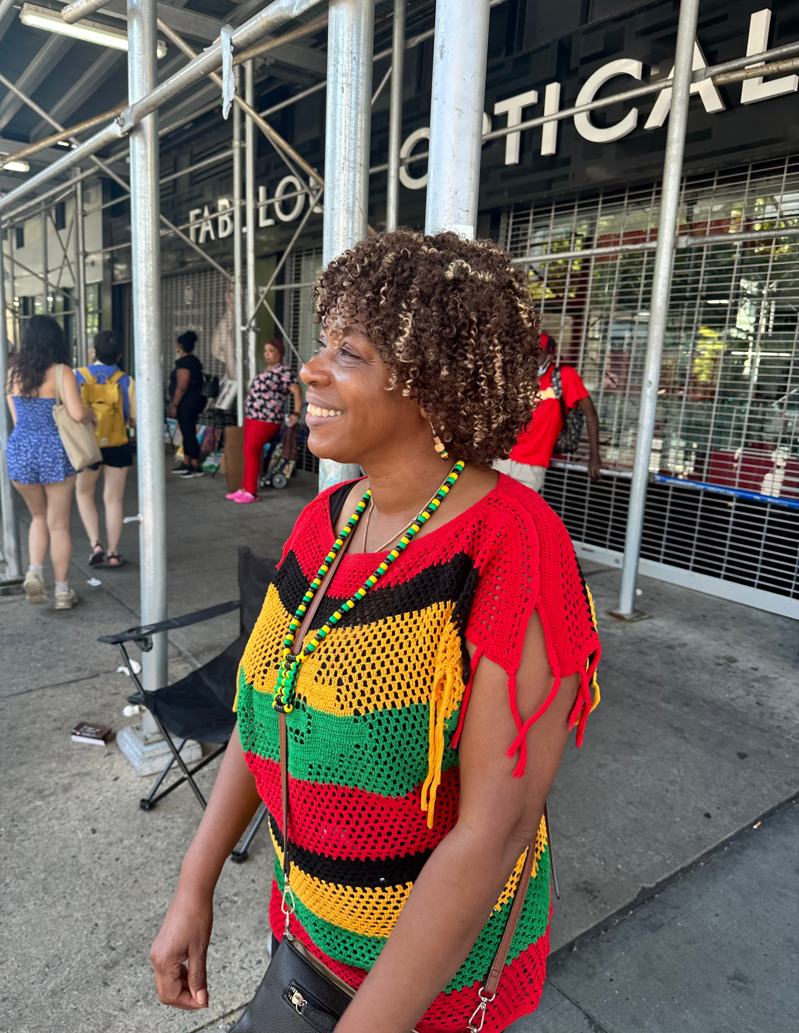
Andrea Nugent dances and looks on as the parade floats go by.

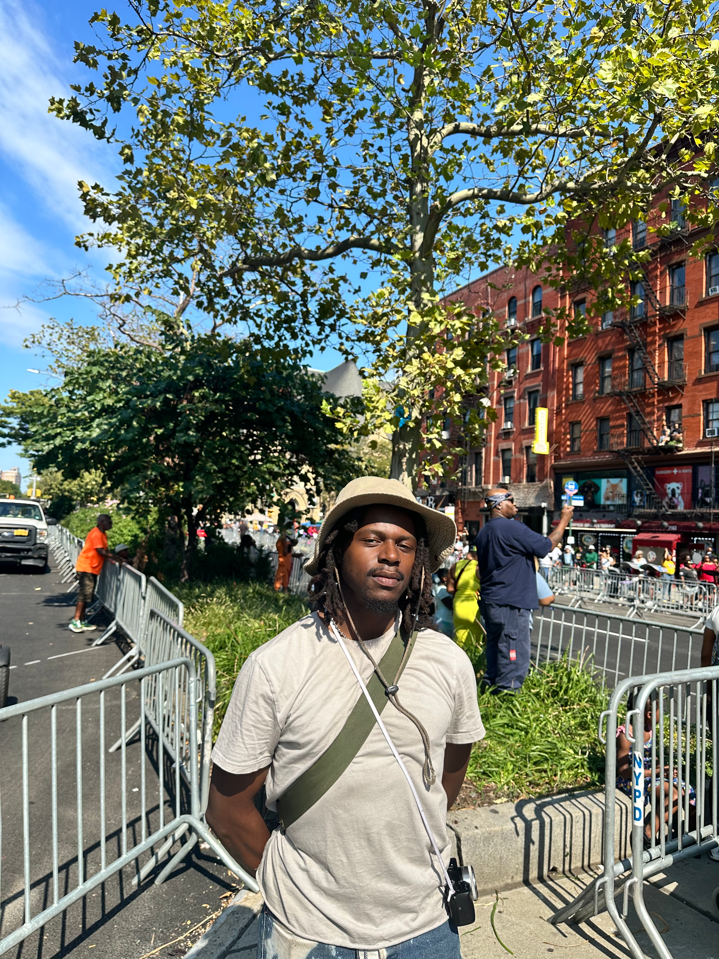
Kyle Jackson, a photographer, poses at the African American Day Parade

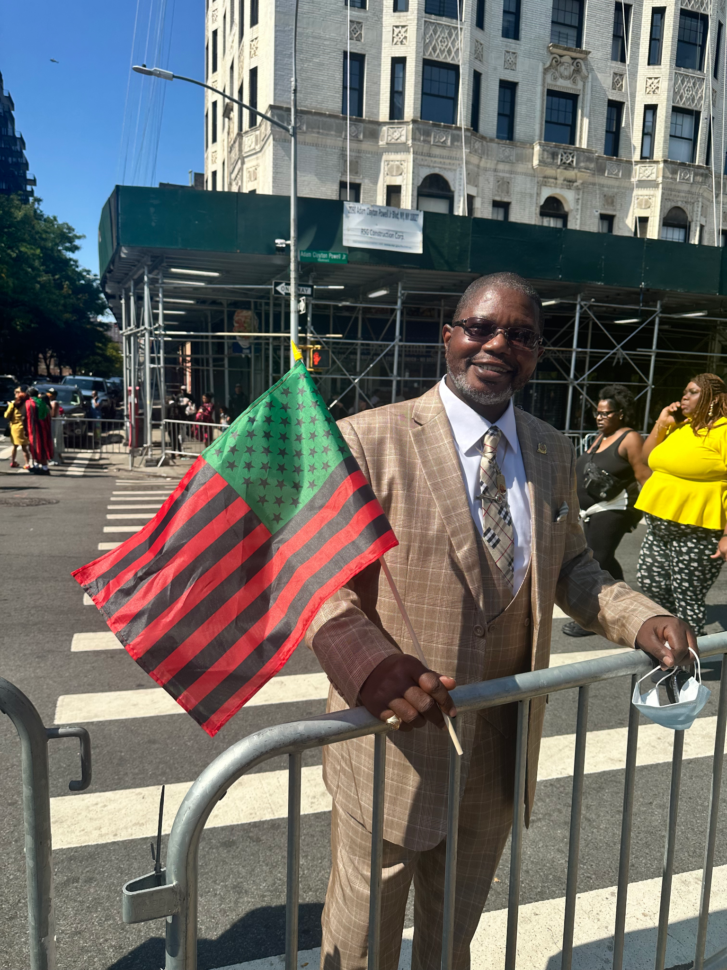
Gerald Grubb celebrates his retirement from law enforcement at the African American Day Parade
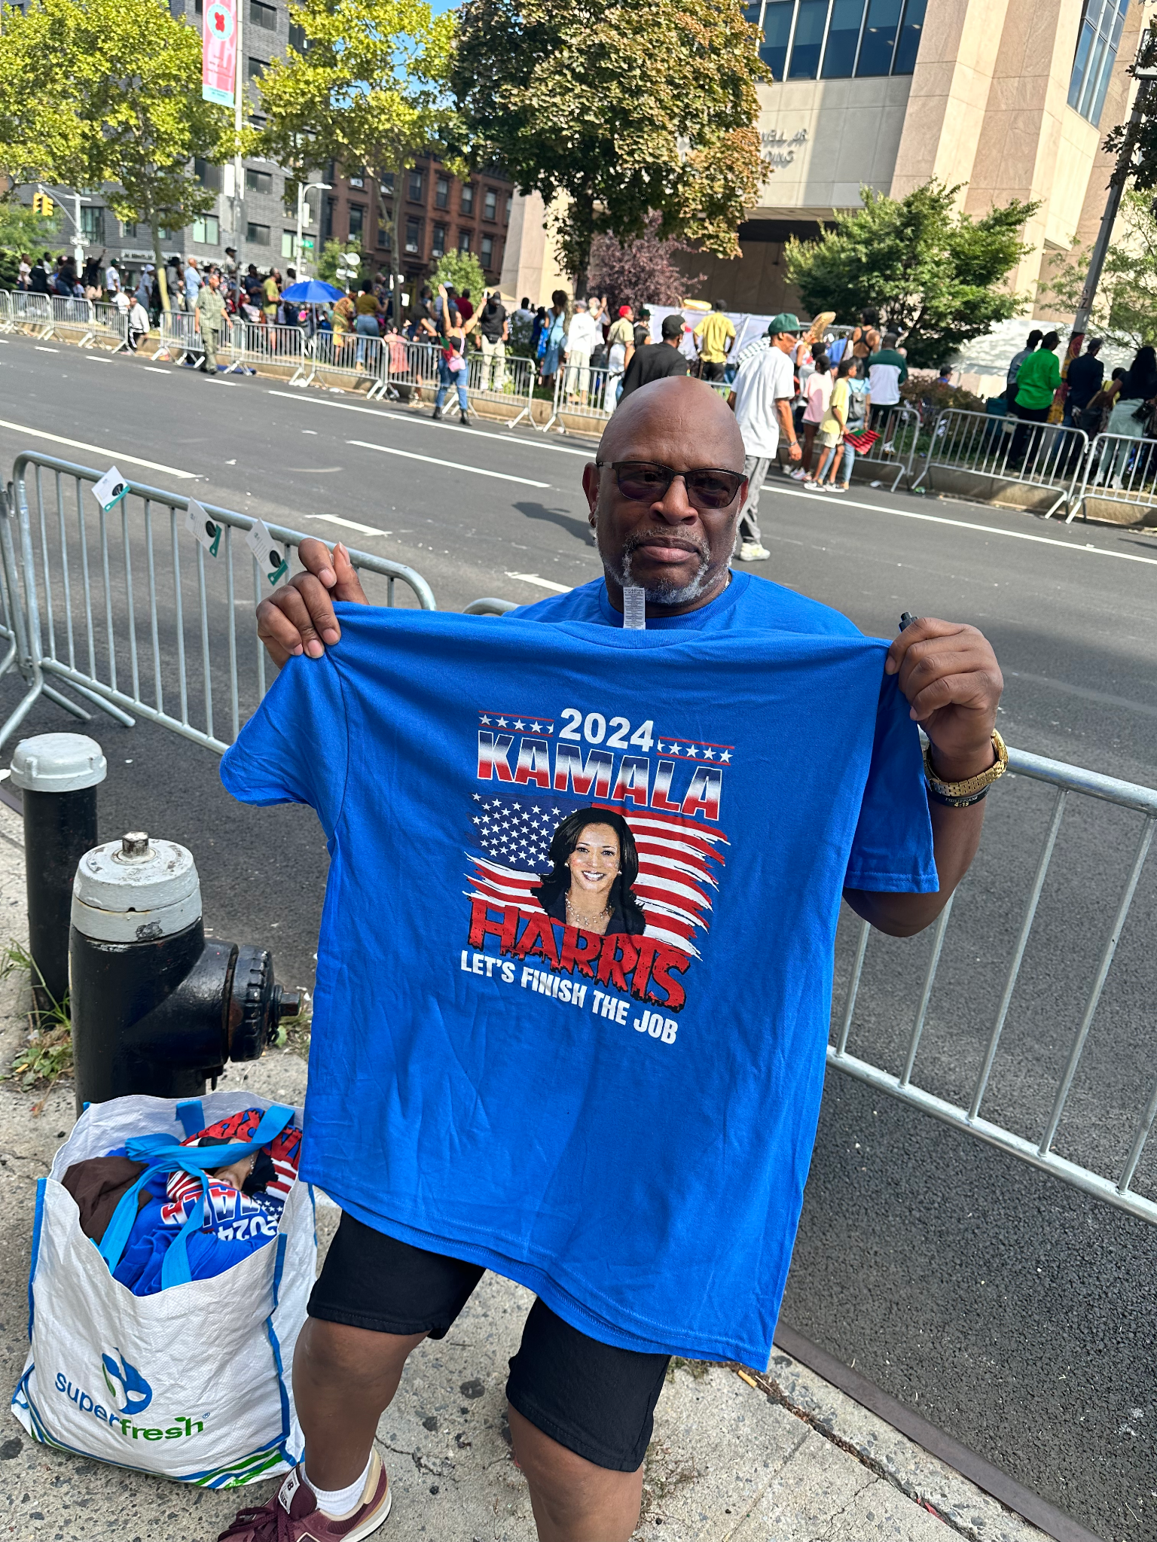
Ivan Smith holds up a ‘Kamala Harris 2024’ t-shirt.

Unity among the community for past and future generations weighed on the mind of some parade-goers. Ivan Smith, 62, worries about young people’s lack of participation at the polls. “A lot of the younger kids don’t understand what our people went through just to have the ability to vote. They have no idea, they need to be more educated about that. I talk to a lot of young people, ‘I’m not going to vote, my vote doesn’t mean anything,’” he said.

Source Links

https://africanamericandayparade.org/#home
https://abc7ny.com/post/african-american-day-parade-2024-when-route-how-watch-nycs-55th-annual-celebration/15278012/
https://www.pewresearch.org/short-reads/2024/01/10/key-facts-about-black-eligible-voters-in-2024/

Social Media Post
The 55th annual African American Day Parade kicked off in Harlem, honoring political leaders within the African American community and serving as a reminder to vote. Read more here: https://mystory.mystory.com

Source List

Andrea Nugent - (347) 225-3325
Gerald Grubb, Brooklyn, (917) 848-1398
Kyle Jackson, 27, Harlem, (631) 626-4712
Ivan Smith, 62, dsincu@gmail.com

