Spot #3 October 7th, 346 words
October 5, 2024
By Emma Rosenberg

Pro-Palestine Protests Erupt Amid One Year Anniversary of October 7th Attack
New York City is set to see increased protests ahead of the first anniversary of the Israel-Hamas war.

Hundreds of protesters gathered in Times Square Saturday, chanting in solidarity with Gaza, and demanding an end to escalating violence in the Middle East. The protest comes amid the ongoing conflict and just days before the one-year anniversary of Hamas’ attack on October 7th.

At the front of the crowd, Isabella–who declined to give a last name–a speaker for the Palestinian Youth Movement, led the crowd in chants.

“We demand an end to the ongoing siege on Gaza, and for freedom of all our political prisoners, and for the liberation of Palestine in its entirety from the river to the sea,” she yelled as protesters with Palestinian flags and a variety of signs looked on.

The protest in the center of New York City is part of many starting this week. Protesters against the conflict urged for a ceasefire amid devastation in Gaza and Lebanon.

Headed by the Palestinian Youth Movement, the demonstration comes ahead of the first anniversary of the October 7th attack. On October 7th, 2023 militant group Hamas launched a large-scale attack on Israel, marking a significant escalation in the Israel-Palestine conflict.

Hannah Kloos, a pro-Palestine protester, highlighted the strength and endurance of the movement noting the significance of old and new attendees.

“It really just illustrates the power of this movement and the staying power that people will be here until Palestine is free,” she said.
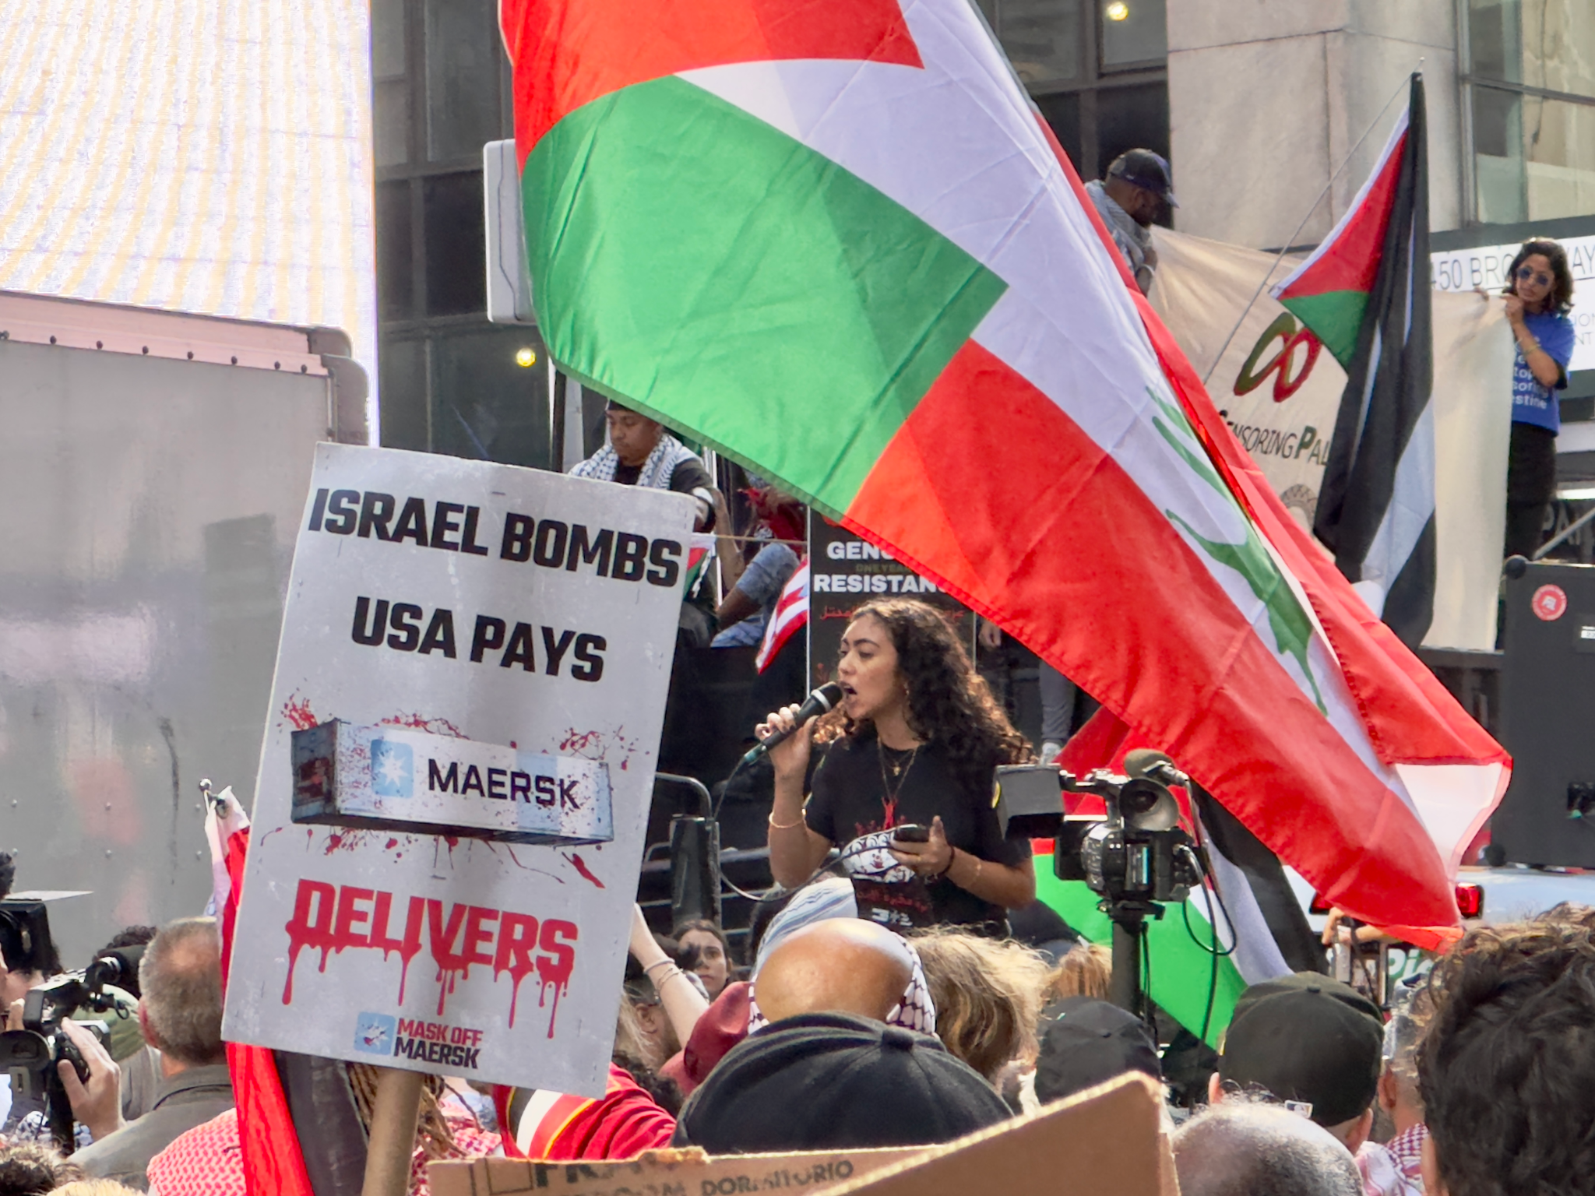
Isabella, a speaker for the Palestinian Youth Movement, leads the crowd in chants against the ongoing devastation in Gaza and the Middle East.

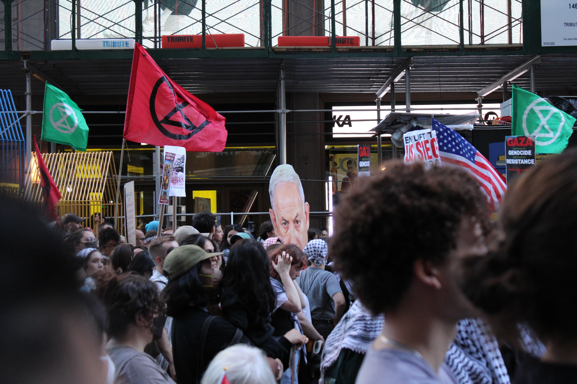
A cutout of Israeli Prime Minister Benjamin Netenyahu floats over the crowd.

For protester John Leslie, who stood handing out flyers supporting an independent labor party, showing up to protest is both personal and political. Leslie explained he objects to the use of tax dollars to fund the war recounting a story about a friend in high school who was driven out of the West Bank.

“This has been an issue for me since high school, because we had a young woman in my high school class. Her family left the West Bank after 1967 they were driven out,” Leslie said.
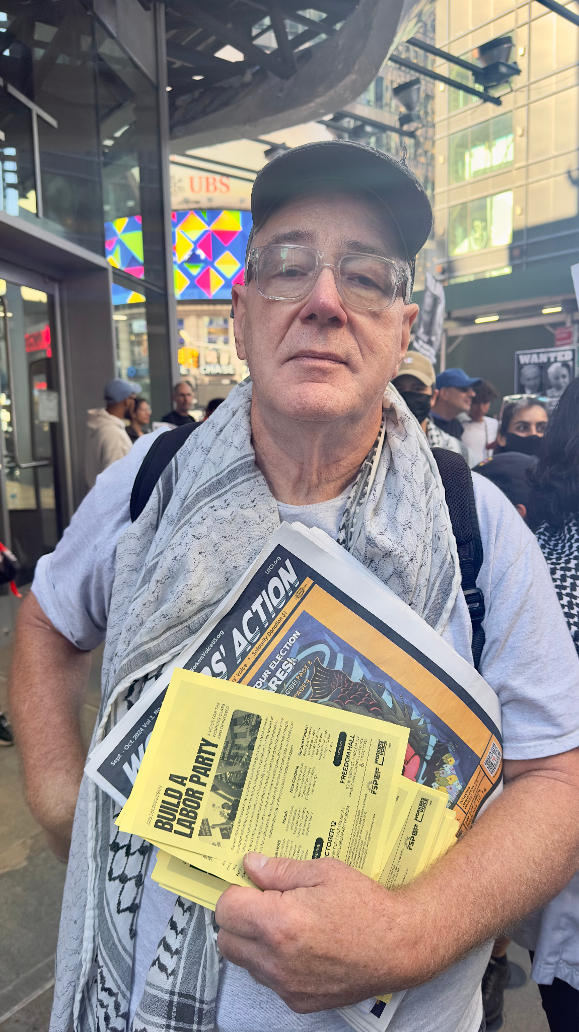
John Leslie hands out flyers calling for an independent labor party at the Pro-Palestine protest Saturday.

Across the street, standing with a handful of Pro-Israel counterprotesters, Roman (who declined to provide a last name) had American and Israeli flags draped over his shoulders. He expressed mixed emotions on the conflict and sympathy for everyone involved.

“It hurts my heart. I feel sorry for everybody that’s affected in this war. If we didn’t have an Iron Dome, Israel would be gone and they support terrorism. It’s a no brainer,” he said.

Source List

Isabella- Speaker PYM

John Leslie- 267-994-9448

Hannah Kloos- hannahkayklo@gmail.com

Roman-Pro-Israel-(declined to give last name or contact information)

+++

Social Media Post

Pro-Palestine protesters took to the streets in Times Square, Saturday to demonstrate against the ongoing war in Israel. Read More: https://myarticle.myarticle.com #Protest #Israel #Palestine

